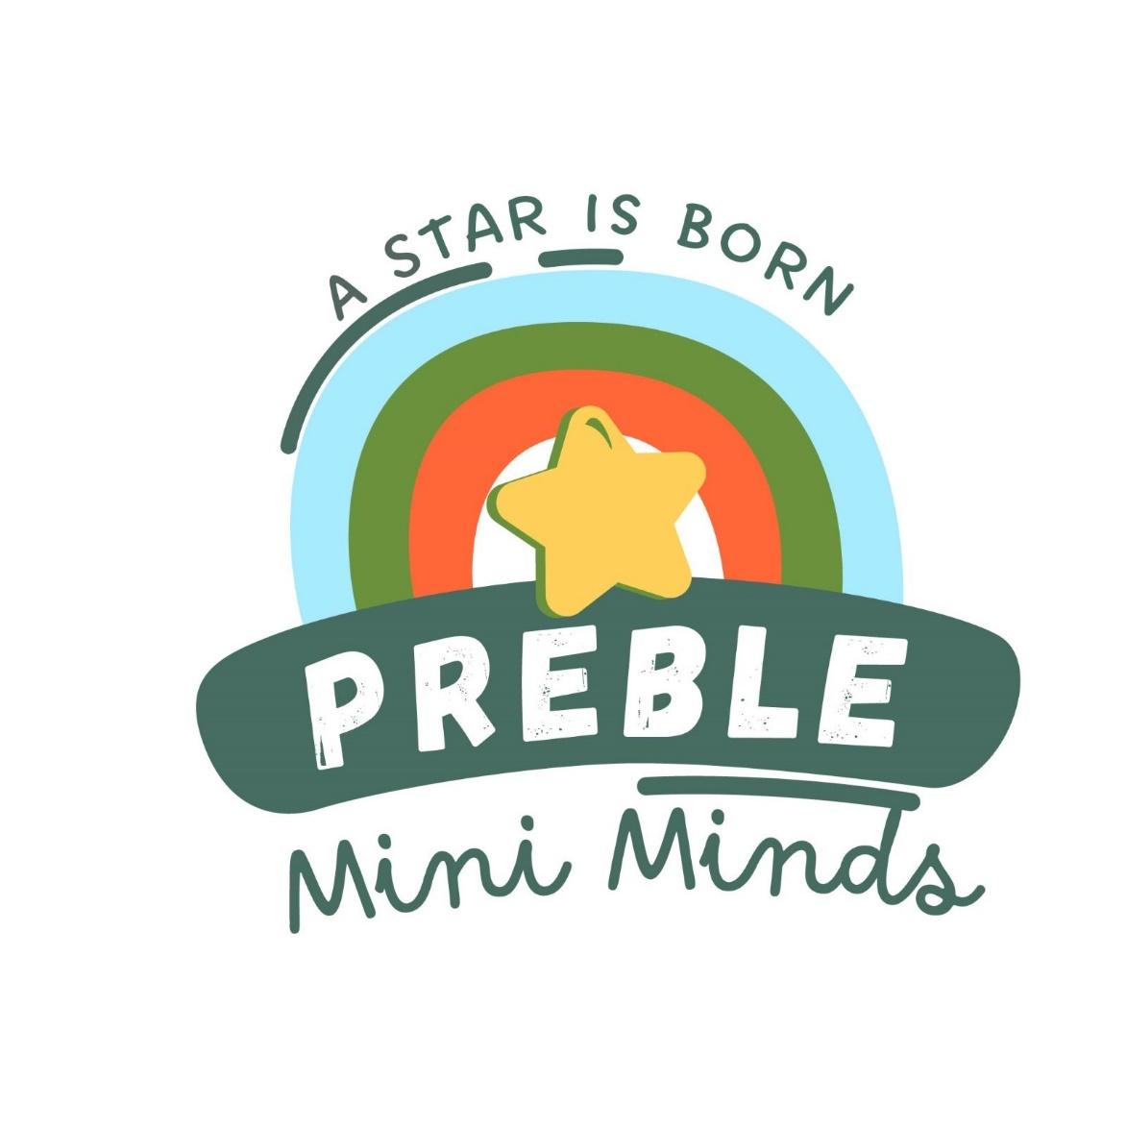  
**Preble Mini Minds Child Care**

Job Description: Teacher

**Qualifications:**

* Hold a CDA, Associate or advanced degree in Early Childhood Education
* Experience working with youth
* Knowledgeable of Developmentally Appropriate Practice
* Knowledgeable of classroom management Skills
* Willingness to be coached
* Willingness to work as a team member and develop new ideas to promote the organization
* Believes good attendance is the foundation for success
* Must pass Criminal Background Check and be free of communicable diseases.

**Description:**

The teacher will plan educational experiences in the areas of language, literacy, math, science, social emotional and physical based on each child’s individual development and needs. The teacher will work as a team member to provide and maintain a fun and safe environment where each child and their family feel welcome. The teacher agrees to further their expertise in child development through professional days, on line training and coaching. The teacher will represent the philosophy of the organization to both children and families and be part of growing the early childhood movement.

Essential Functions:

* Plan and implement learning experiences to further children’s growth in language, literacy, math, science, social emotional and the arts.
* Evaluate children’s learning through daily documentation and observations.
* Reflect on learning objectives to create plans that are individualized for each child.
* Be the leader of the classroom to both adults and children and create an environment of inclusiveness.
* Facilitate parent activities, meetings and conferences.
* Work as a team member with other classrooms and age groups to ensure a smooth transition process.
* Participate in personal, professional growth and the growth of the organization.
* Ensure the safety of children in the classroom, building and in your care off site.
* Promote nutrition and well being through meals, physical activity and information relayed to parents.
* Ensure confidentiality is upheld for children, families and the organization.
* Communicate with leadership regarding progress, concerns and recommendations.
* Ensure policies are upheld by yourself and those interacting in your classroom.
* Use technology as a tool to aid in the above functions.

Terms of Employment:

* At Will Employment based on evaluation of the above functions.
* Salary is set by the Preble Mini Minds Board yearly based on education and experience.
* Employee policies are reviewed, signed and monitored.

Benefits:

* Hourly Wage/Salary based on education and experience
* Personal Time off
* Health including vision and dental