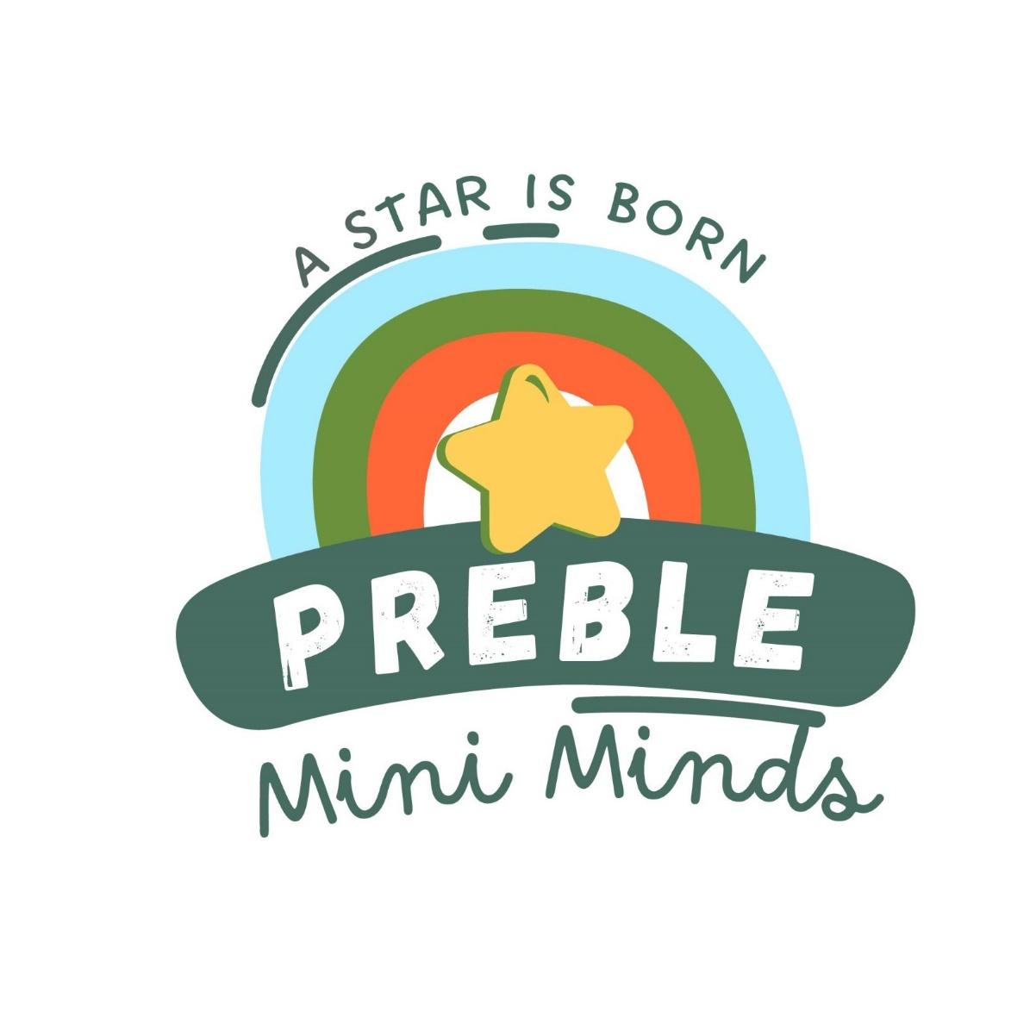  
**Preble Mini Minds Child Care**

Job Description: Assistant Teacher Floater

**Qualifications:**

* Highschool Diploma or equivalent
* Experience working with youth
* Willingness to be coached
* Willingness to work as a team member and develop new ideas to promote the organization
* Believes good attendance is the foundation for success
* Must pass the prescribed Criminal Background Check and be free of communicable diseases.

**Description:**

The assistant teacher floater will follow the planned educational experiences in the areas of language, literacy, math, science, social emotional and physical based on each child’s individual development and needs. The assistant teacher floater will work as a team member to provide and maintain a fun and safe environment where each child and their family feel welcome. The assistant teacher-floater agrees to further their expertise in child development through professional days, online training, and coaching. The associate teacher floater will represent the organization's philosophy to both children and families and be part of growing the early childhood movement.

Essential Functions:

* Aid in all age groups based on the ratio
* Be flexible in the daily schedule to provide classroom teachers breaks and planning time
* Help implement learning experiences to further children’s growth in language, literacy, math, science, social, emotional, and the arts.
* Record children’s learning through daily documentation and observations.
* Work as a team member with other classrooms and age groups to ensure a smooth transition process.
* Participate in personal and professional growth and the growth of the organization.
* Ensure the safety of children in the classroom, building, and in your care off-site.
* Promote nutrition and well-being through meals, physical activity, and information relayed to parents.
* Ensure confidentiality is upheld for children, families, and the organization.
* Communicate with leadership regarding progress, concerns, and recommendations.
* Ensure policies are upheld by yourself and those interacting in your classroom.
* Use technology as a tool to aid in the above functions.

Terms of Employment:

* At-will employment based on evaluation of the above functions.
* Hourly wage is set by the Preble Mini Minds Board yearly.
* Employee policies are reviewed, signed, and monitored.
* Must pass the prescribed Criminal Background Check and be free of communicable diseases.

Benefits-Part time:

* Flexible schedule
* Paid training
* Opportunities for advancement
* Hourly Wage based on experience