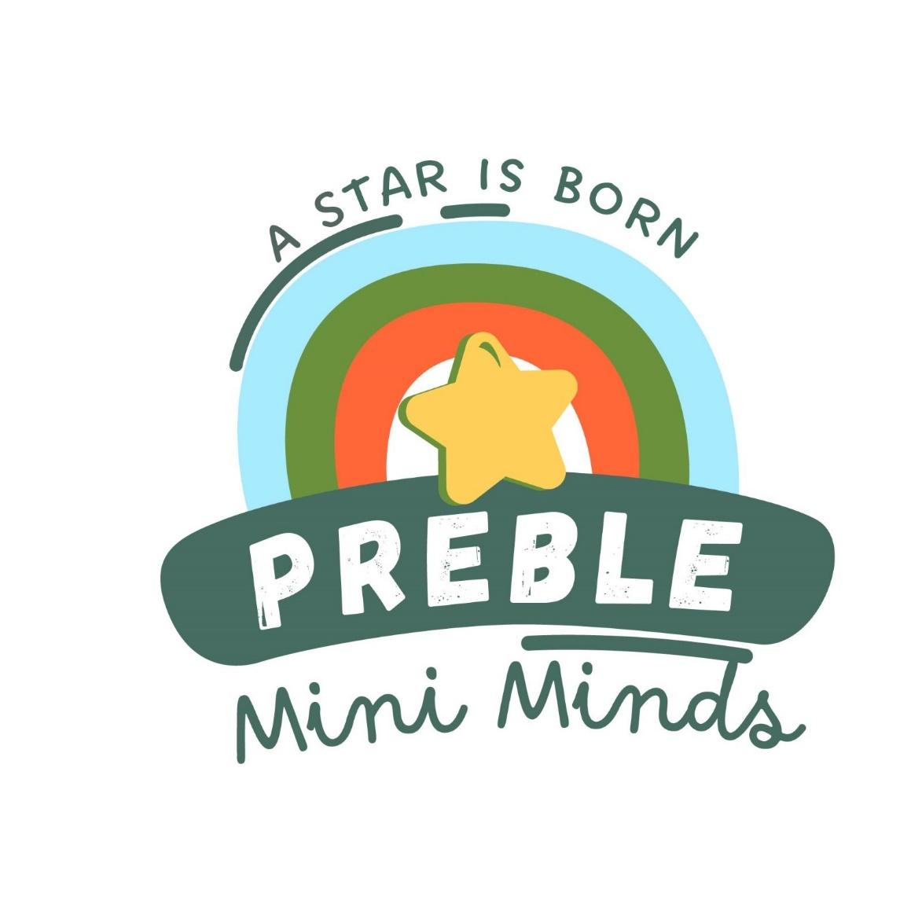  
**Preble Mini Minds Child Care**

Job Description: Administrative Assistant

**Qualifications:**

* Hold a higher degree in Early Childhood Education or a related field
* Experience in office management
* Experience in administrative tasks, including Microsoft Office
* Willingness to work as a team member and develop new ideas to promote the organization
* Believes good attendance is the foundation for success
* Must pass a Criminal Background Check and be free of communicable diseases.

**Description:**

* Communication: answering and directing phone calls, responding to inquiries, and composing correspondence when needed or directed to.
* Schedule: organizing and scheduling appointments, meetings and activities
* Record Keeping: maintaining contact lists, records, files, and inventories (collecting payments); Interpreting and maintaining applicable laws, codes, rules, and regulations.
* Supplies: Ordering office and classroom supplies
* Assisting visitors, monitoring the entrance, helping with registration/enrollment
* Assist the director in maintaining a healthy, ongoing, positive environment for families, children, and staff
* Update forms for the Center
* Update and maintain a spreadsheet of employee certifications and expiration dates.
* Update and maintain spreadsheets as needed to track Child Care Centre-related information.
* Take minutes at staff meetings, administration meetings, and school meetings
* Ensure the program’s website and social media information is maintained in consultation with the Director.

Essential Functions:

* Monitor and aid in all center functions
* Assist the director in all safety practices and building procedures
* Ensure policies are upheld by yourself and those interacting in the facility.
* Be the responsible personnel in the director’s absence
* Participate in personal and professional growth and the growth of the organization.
* Ensure confidentiality is upheld for children, families, and the organization.
* Communicate with the director regarding progress, concerns, and recommendations.
* Use technology as a tool to aid in the above functions.

Terms of Employment:

* At-will employment based on evaluation of the above functions.
* Salary is set by the Preble Mini Minds Board yearly based on education and experience.
* Employee policies are reviewed, signed, and monitored.
* Must pass the prescribed Criminal Background Check and be free of communicable diseases.

Benefits:

* Hourly Wage/Salary based on education and experience
* Personal time off
* Health, including vision and dental